Rithvik Charan.R

192111733

CSE

11. Create a simple cloud software application for online super market using any Cloud Service Provider

Application :

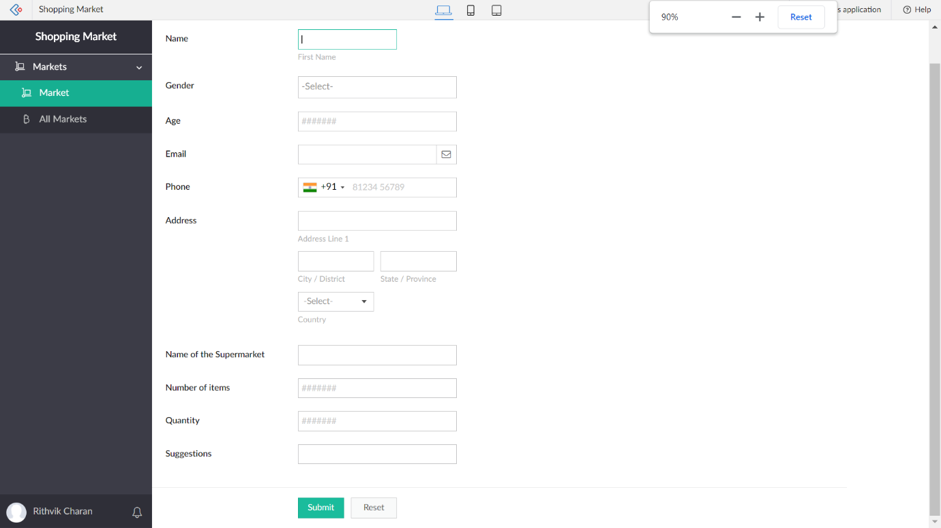

Response :

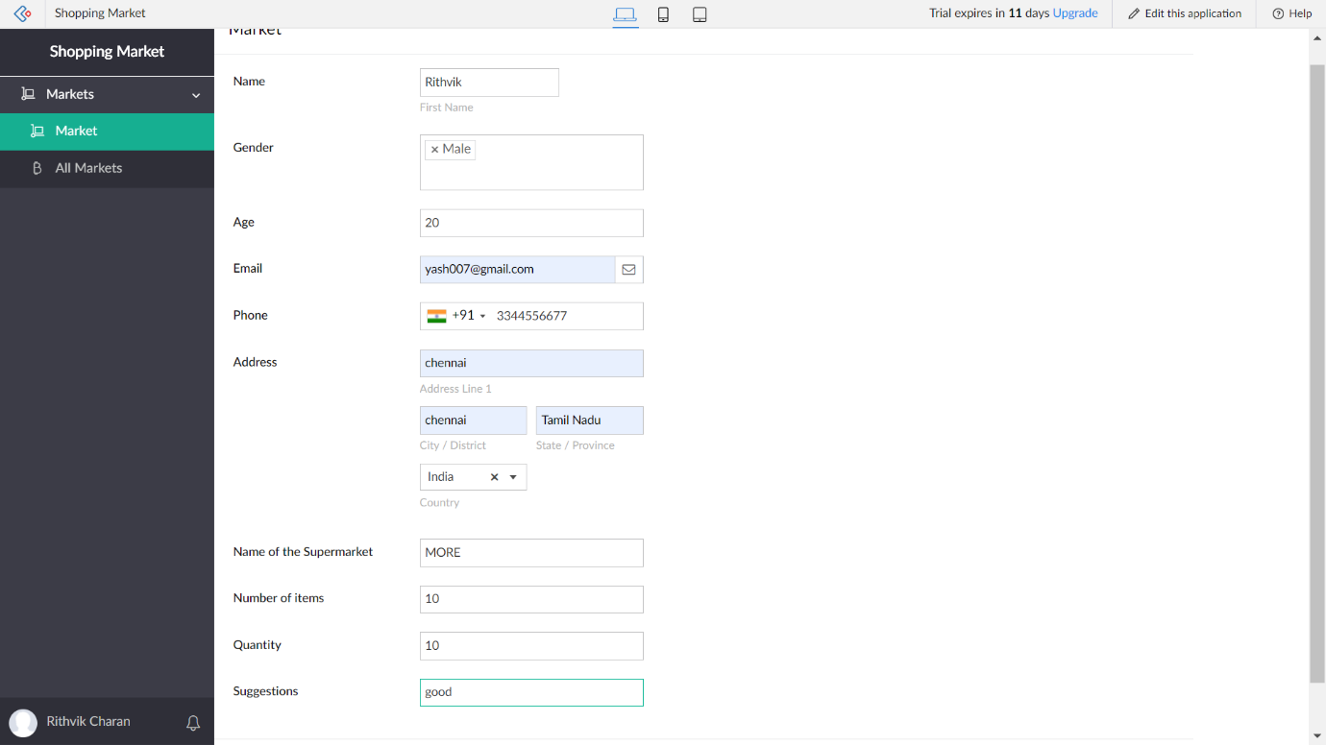

Report :

